

A Miraculous Catch of Fish
Luke 5:1-11
Talk About This…
- What are amazing things you’d love to see Jesus do?

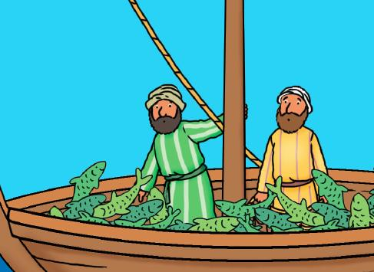
Through the Week
- To set up, cut some simple fish shapes out of paper, and hang up a paper lunch bag.
- Put the fish and a pen next to the bag.
- Throughout the week, be on the lookout for “God Sightings”—amazing things Jesus is doing in your lives.
- Whenever anyone has a God Sighting to share, he or she can write it on a fish and put it in the bag.
- Try to fill the bag with fish!
- At the end of the week, read what’s written on all the fish. Celebrate the amazing things Jesus did for your family!
Jesus finds some fishermen, frustrated after a night with no catches. Jesus tells them to let down their nets again, and when they do, there are so many fish that they have to call for help lifting the nets! They’re amazed because Jesus is amazing.
CLM Kids Church

VBS Rainforest Falls

Aug. 9-12, 6:30-8:30 pm
“Many will see what he has done and be amazed.
They will put their trust in the Lord” (Psalm 40:3).



