

Jesus Is Rejected
Luke 4:16-30
How I Show Love
Play this game as a family to learn more about how to show one another Jesus’ love.
- Have family members take turns being the “Voter.”
- The Voter will choose one of the following sentence starters. Everyone else will say the answer they think best fits the Voter.
  - One thing I think Jesus loves about me is...
  - It makes me feel loved when...
  - I most like to show others love by...
  - I don’t feel loved when...
  - I’d like to show Jesus’ love to...
- The Voter will select his or her favorite answer and explain why.
- Play until everyone has been a Voter at least twice. (It’s okay to repeat questions.)
- Talk about how you can use what you learned to show each other more love this week.
Family Discussion
- How is Jesus’ love different from your love?
- Who’s someone you have a hard time showing Jesus’ love to?
- What can you do this week to show that person Jesus’ love?

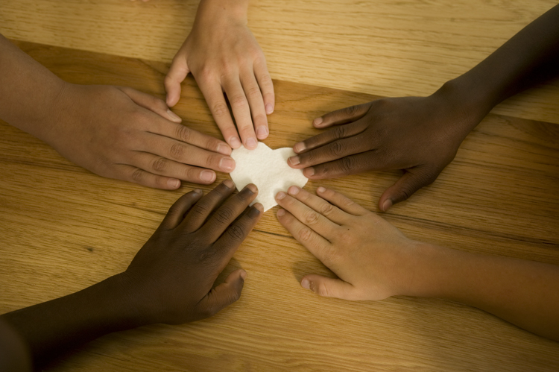
Jesus visits his hometown synagogue and reads some words from the book of Isaiah about coming to help the captives and the blind. He also says that he came for everyone, not just Jews. The people of Nazareth were not pleased to hear that Jesus loves everyone.
CLM Kids Church

VBS Rainforest Falls

Aug. 9-12, 6:30-8:30 pm
“When Jesus heard this, he told them, ‘Healthy people don’t need a doctor—sick people do. I have come to call not those who think they are righteous, but those who know they are sinners” (Mark 2:17).
Through the Week
Here’s an activity you can do throughout the week.
- When you’re out in public, look for people you don’t know.
- Make up stories about those people. What do they like? What’s their family like? How are they hurting?
- Try to see those people through Jesus’ loving eyes.
- Pray together for the people you’ve seen, that they’ll know Jesus loves them.
- If you have a chance, show the people Jesus loves them.

