You Must Be Born Again
John 3:3-7 We enter the physical world, our family, by physical birth. We enter God’s kingdom, his family, by spiritual birth.
John 3:8 We can’t see the wind, but we can feel it and see its effects.

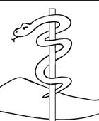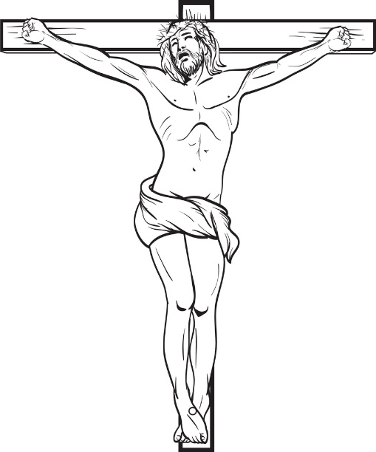
Numbers 21:5-9 John 3:14, 15
*How was the snake on a pole a picture of Jesus on the cross?

To be born again, we need God’s ________ 1 Peter 1:23
and God’s ____________ John 6:63.

God’s Spirit convicts us of our sin and draws us to believe God’s word in our hearts that Jesus is Lord. His Spirit comes in & we are born again.

John 11:25-27 Is God’s Spirit drawing you to believe?

*How can you grow closer to Jesus?

