
Easter Sunday
Luke 23:26–24:12
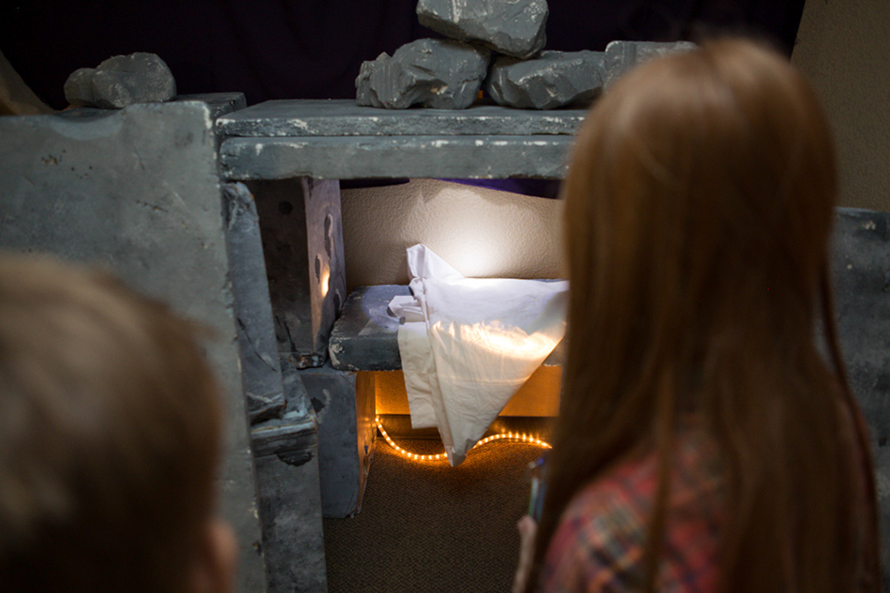
Rising Arms
- You’ll need two people for this trick. Have Person 1 stand up straight with arms against his or her sides. Person 2 will push Person 1’s arms against his or her sides. Person 1 will try to resist Person 2 by pressing his or her arms against Person 2.
- After about a minute, Person 2 should let go.
- Person 1’s arms will raise up automatically!
- Talk about how your arms felt when they lifted up.
- Talk about how wrong things can hold us down.
- Talk about how awesome it is that Jesus is our Savior, and how it feels knowing that he took our punishment so we can one day go to heaven with him.
Jesus is forced to endure the punishment of a criminal—death on a cross—even though he himself is sinless. Why? Because Jesus is our Savior, taking the punishment for our wrongdoings. And then, Jesus comes back to life in three days. Jesus is alive!
CLM Kids Church

It’s time to plan our next event.

What would you like to do?
Family Discussion
- Why do people need a Savior?
- What does it mean for Jesus to be your Savior?

“He isn’t here! He is risen from the dead!” (Luke 24:6)
Through the Week
Here’s an activity you can do throughout the week.
- To set up, cut apart the Bible verses on the next page. Put each verse in a plastic Easter egg, and hide the eggs around the house.
- Throughout the week, as people find eggs they can open them and read the verses to learn more about how Jesus is our Savior.
- At the end of the week, talk about anything you learned from the verses you read.

