** Psalm 23:**

**Dark Valleys**

**Psalm 23:4; Exodus 13:17-22**

**Here’s what happens…**

In this section of Psalm 23, things take a dark turn…into dark valleys. But God, our shepherd, is still there with us! The Israelites have a hard time when they escape from slavery in Egypt and wander through a desert. But God shows he’s with them through pillars of cloud and fire.

**Bible Point:**

God is with us in hard times.

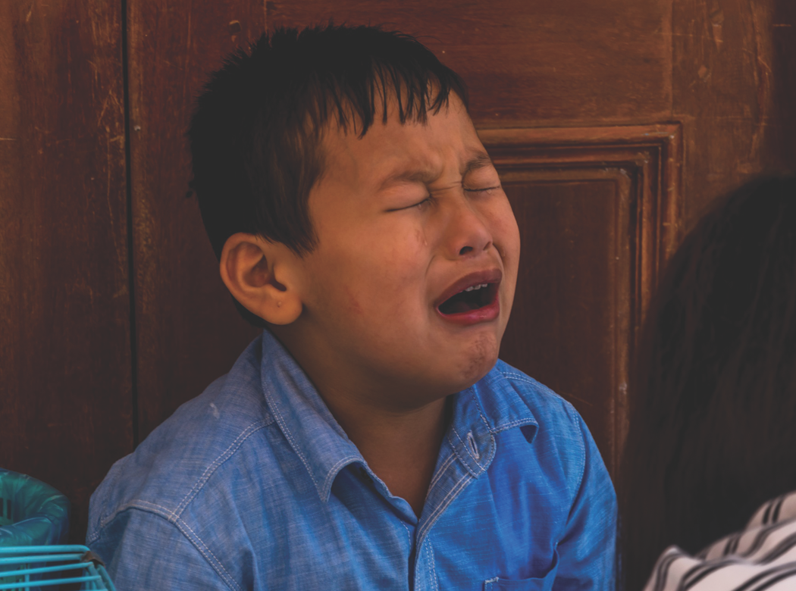

**CLM Kids Church**

Sun. Sep. 28 Service & Picnic

**Through the Week**

* Get a cotton ball for each person in your family.
* Read Psalm 23 together.
* Give your cotton ball “sheep” names.
* Review Exodus 13:17-22 together to see how a cotton ball can also remind you of the cloud that represented God’s presence with the Israelites.
* Carry your sheepy clouds with you all week as a reminder that our shepherd, God, is always with us. You might put them in a pocket, purse, or backpack.

**Talk About This…**

* What things in your life feel hardest right now?

*“The Lord is my shepherd; I have all that I need”*

*(Psalm 23:1).*