**God’s Commandments:**

**No Idols**

**Exodus 20:4-6; 2 Kings 23:1-20**

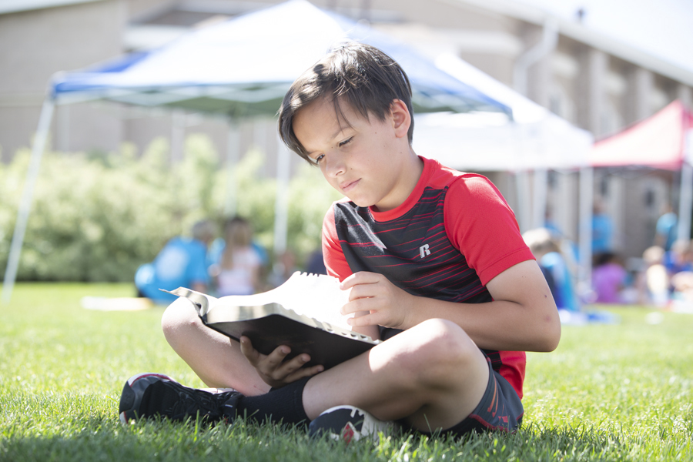

**Here’s what happens…**

After finding and reading God’s law, King Josiah starts taking the worship of the one real God seriously. He goes from place to place in Israel burning and smashing idols and altars. By the time he’s finished, any evidence of worshipping fake gods is gone!

**Bible Point:**

There’s only one real God.

CLM Kids Church

**Mexican Lunch and Bowling**

Sat. March 22

**Meet at Jalapenos at 12:00 Noon**

13130 Kingston Ave. Chester 23836

**We’ll drive to Hopewell Bowl after lunch**

115 S. 15th Ave.

**Talk About This…**

* What’s one thing you know for sure is true about God?

**Family Together Time**

Go on a prayer walk around your neighborhood.

* As you pass each house, pray for the people who live there to know the one real God.
* If you know the people who live there and what they believe, add specifics to your prayers!
* Ask God to show up in such a real way that your neighbors can’t deny who he is.
* Ask God to use *you* to show your neighbors who he is!

*“Jesus replied, ‘You must love the Lord your God with all your heart, all your soul,*

*and all your mind’ ” (Matthew 22:37).*