

**Acts: God Sends Aquila**

**and Priscilla to Help Paul**

**Acts 18:1-28**

While traveling, Paul meets Priscilla and Aquila. This couple makes tents for a living, just like Paul. He stays with them, and they join him in ministry. They’re more behind the scenes than Paul, but God uses those talents to help spread his message. God uses our talents.

**Through the Week**

Make a reminder for your family that everywhere you go this week, God can use your talents.

* Make a sign that says, “You are now entering the mission field.”
* Have everyone help decorate the sign with thumbprints and pictures that represent their talents.
* Hang the sign on the door you use most often when you leave.
* Whenever you pass through that door, stop and look at the sign, and ask God to use your talents as you enter your mission field—wherever you’re going.



**CLM Kids Church**

**Service, Picnic, & Pumkin Carving**

**Sunday October 27**

*“But we are citizens of heaven, where the Lord Jesus Christ lives. And we are eagerly waiting for him to return as our Savior” (Philippians 3:20).*

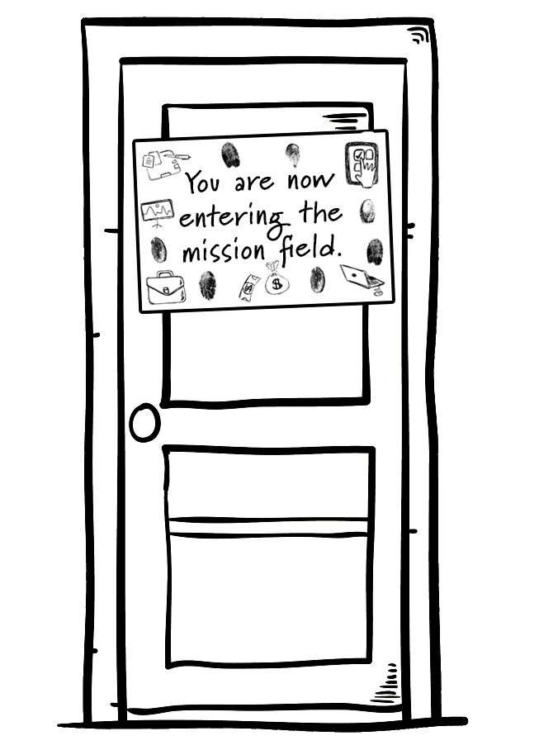

**Talk About This…**

* If you were going to be on a reality TV show that shows people’s talents,

what talent would you show off? Do you think you’d win?